# Micro Site Storm Model

WikiWatershed

Day 2

This simple model (not so simple underneath the hood) allows the user to explore the interplay of the major factors governing the fate of rainfall hitting the earth. It’s a good precursor for those that will be using the full Model My Watershed tool. Description from the website*: “*The Runoff Simulation Modelis an animated version of the Site Storm Model package of Model My Watershed. It allows users to learn how land use and soil together determine whether rainfall infiltrates into the soil, runs off into streams or is evaporated and transpired by plants.”

### Open the Runoff Simulation Tool

### 1. Go to WikiWatershed Home Page of the Stroud Water Research Center

[**https://wikiwatershed.org/**](https://wikiwatershed.org/)

2. Launch the Runoff Simulation App

Spend some time playing with the three variables of the model: rainfall amount, land cover type, and soil type (see diagram, next page). Then, answer the questions on the following page.

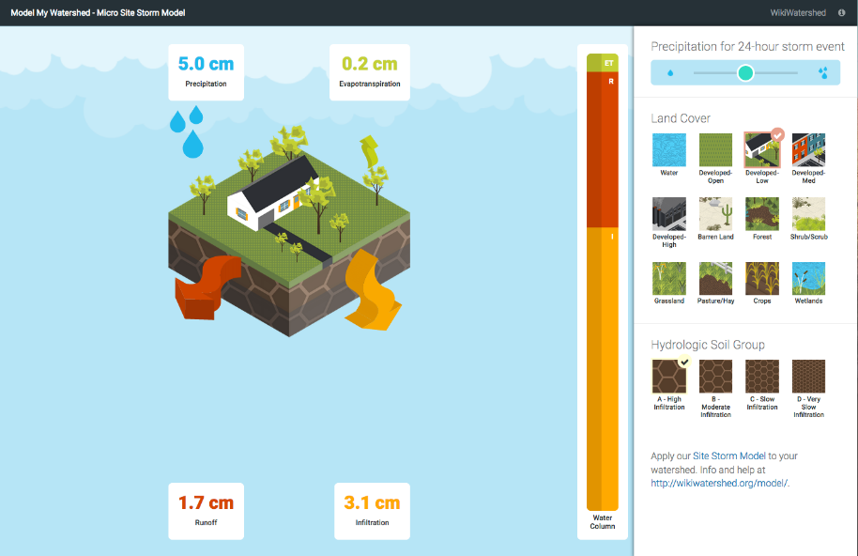

choose a land cover

adjust size of storm event

choose a soil type

Note where the water goes

3. Keeping the rainfall setting at 5 cm and soil type “A” (the default settings), choose different land covers and note the difference in the results of what happens to the rainfall.

*Q: What is the difference in runoff generated by a 5 cm storm (the default setting) between forest and highly developed land? _________ Between crops and low intensity developed land? _________*

*Q: What percentage of a 5 cm rainfall becomes runoff in medium intensity developed land? ____*

4. Adjust the soil type for 2 or 3 different land covers.

*Q: For the three developed classes, what changes occur in infiltration and runoff with different soil types? ____________________________________________________*

*Q: For grassland and crops, how does the infiltration and runoff change as the soil goes from “A” to “D”? __________________________________________*

5. Finally, see what happens when a bigger storm arrives. Choose a land cover and soil type and move from the 5 cm to the 8 cm to the 21 cm storm settings.

*Q: Circle the land cover that does the best job of infiltrating large storms:*

*developed/open forest grassland wetland*

*Q: For a 21 cm storm, what percentage of the rainfall becomes runoff for a medium intensity developed area with highly infiltrating soils? ______*